

ITA0324-Mobile Computing

Name: A. Anusha Reg no:192472083

Slot: C Course Name: Mobile Computing

Experiment 12: Evolution from 1G to 5G
Aim: To create an interactive diagram illustrating the evolution of mobile networks from 1G to 5G.
Procedure:
- Open Figma and create a new design file.
- Create a horizontal timeline representing five generations.
- Add separate sections for 1G, 2G, 3G, 4G, and 5G.
- Include the main technologies and features of each generation.
- Add examples such as analog voice, digital calls, mobile internet, broadband, and low-latency connectivity.
- Use icons, colors, and arrows to show the evolution.
- Add clickable interactions in Prototype mode to display details about each generation.

Output:
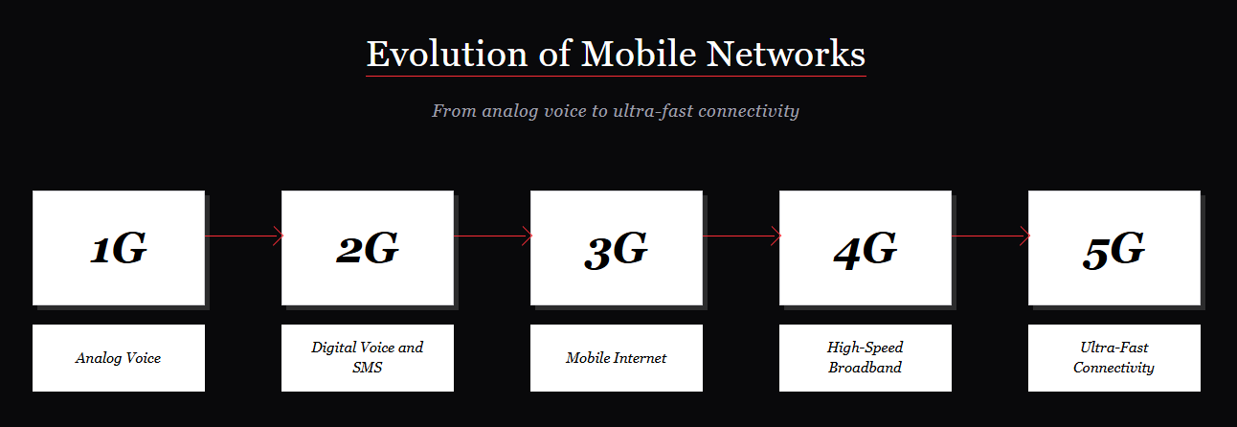

Result: Thus, an interactive diagram illustrating the evolution of mobile networks from 1G to 5G was created successfully using Figma.

